CAPABILITIES STATEMENT
deerwalk®

CORE COMPETENCIES
Deerwalk’s Population Health Analytics, reporting and data warehousing solutions provides large, self-funded employer groups meaningful insights to better manage the cost, quality, and risk of their health plan by:
Gaining complete visibility into the health of your employee, dependent and retiree population
Stratifying risk of your population and determine biggest cost drivers
Understanding chronic conditions, identify gaps in care and risk triggers in your population
Identifying wasteful and unnecessary medical utilization (ER visits, admissions)
Reviewing financial plan performance to budget, fixed cost and stop loss
Maximizing plan design and incentive programs to improve employee health
Measuring the effectiveness and ROI of medical management and wellness initiatives
Benchmarking cost and utilization to like industries and geographic regions
Identifying quality providers with lower cost and better outcomes
Tracking and monitoring utilization and effectiveness of onsite clinics
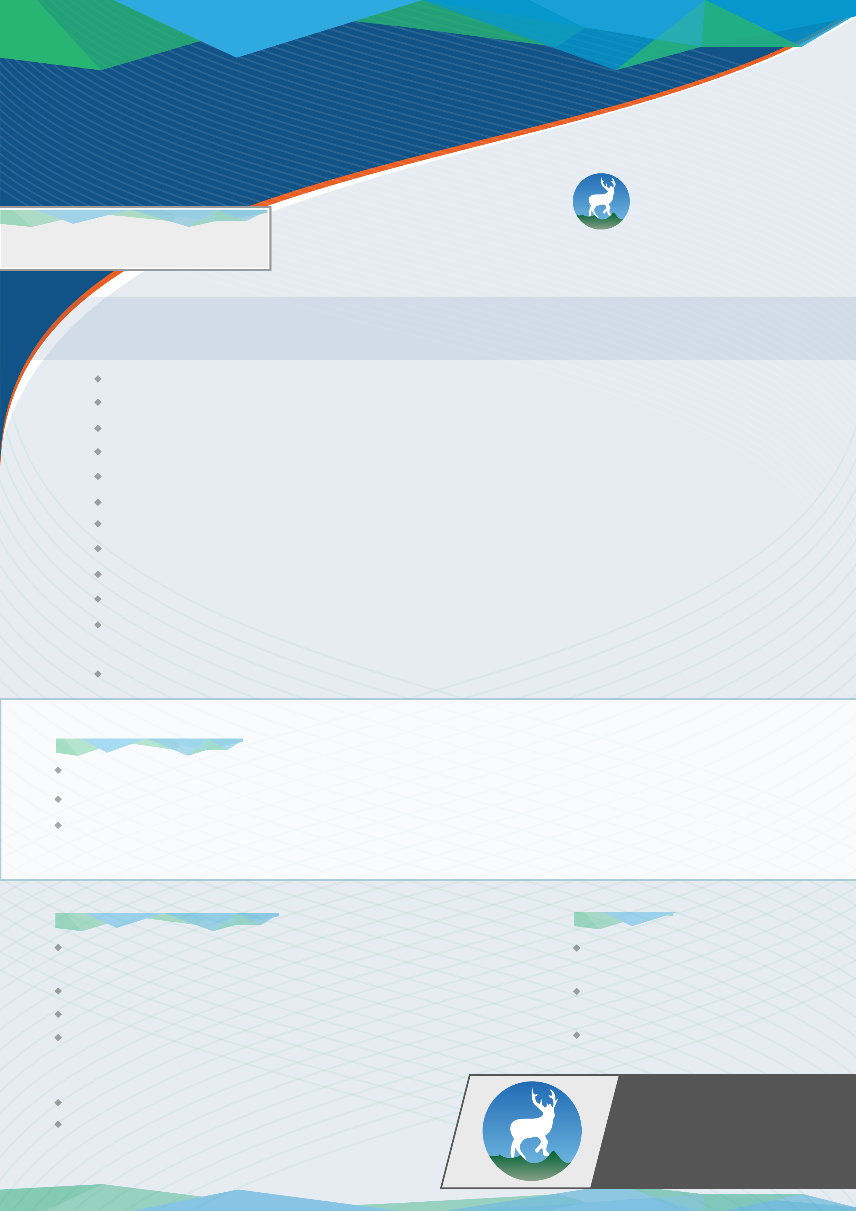
Identifying compliance to preventative care, screenings, immunizations, standards of care and medication adherence
Evaluating the effectiveness of provider networks and worksite clinics

PAST PERFORMANCE
A national wellness company uses Deerwalk to create customized reporting to provide their ROI to its clients
A national cancer clinic company uses Deerwalk to import EMR data to ensure standards of care are being applied
A national benefits consultant uses Deerwalk to calculate ROI on wellness and disease management initiatives of

their employer clients.

COMPANY INFORMATION
Deerwalk offers it’s services nationwide, with over 3 million members on the platform nationally.
Established: 2010 (Private Corp) Certification: GNEMSDC Insurance Coverage:
- Hanover Insurance Group - Commercial General Liability
- Massachusetts Bay Insurance Company - Worker's CompWebsite: www.deerwalk.com NAICS Codes:
511210 541511 541611 541990

CONTACTS
Jeff Gasser, President jgasser@deerwalk.com Tim Huke, VP Sales thuke@deerwalk.com John Cassella, Business Development jcassella@deerwalk.com
430 Bedford Street, Suite 175 Lexington, MA 02420
781-325-1775 www.deerwalk.com

